

**Supplemental Claim Form (20-0995)**

Version 3  
Launch: Late February 2025

Version History

| **Date** | **Version** | **Description** | **Author** |
| --- | --- | --- | --- |
| January 2023 | 1 | Product debut | Sade Ragsdale |
| October 2024 | 2 | Update with error notification | Maurice DeBeary |
| February  2025 | 3 | Update with new form fields | Maurice DeBeary |

## Table of Contents

**Overview**

**User Access**

Who can access these tools?

How can users access these tools?

**Navigation**

**Functionality**

Supplemental claim form

Introduction page

Getting started: Is this the form I need?

Getting started: Check your eligibility, gather info, and get started

Intent to File (ITF)

Form Step 1: Veteran information

Form Step 1: Veteran information: Are you experiencing homelessness or at risk of becoming homeless?

Form Step 1: Veteran contact information

Form Step 2: Add issues to the claim

Add new issues to the claim

Form Step 3: Types of facilities

Form Step 3: Request for VA medical evidence

Form Step 3: Request for private medical evidence

Form Step 3: Upload your records or other documents

Form Step 3: Review the evidence you’re submitting

Form Step 4: Optional indicator for Veterans with claims related to Military Sexual Trauma (MST)

Form Step 5: Review and submit

Confirmation page

**Major Issues and Error Messages**

**Frequently Asked Questions**

Supplemental claim VA Form 20-0095

Should I file a supplemental claim?

What kind of issues can I add to my supplemental claim?

My claim may fall under the PACT Act. Should I file?

I don’t think my claim falls under the PACT Act. Should I file?

**Email Error Notification**

VA Form 21-4142

## Overview

Supplemental claims are one of three options for claimants to request a decision review. They are the most frequently used decision review pathway. A claimant may file a supplemental claim when they disagree with a previous decision and have new and relevant evidence that may establish a theory of service connection.

Note: The Veteran Benefits Administration anticipates a high volume of supplemental claims to be filed by Veterans due to the PACT Act.

## User Access

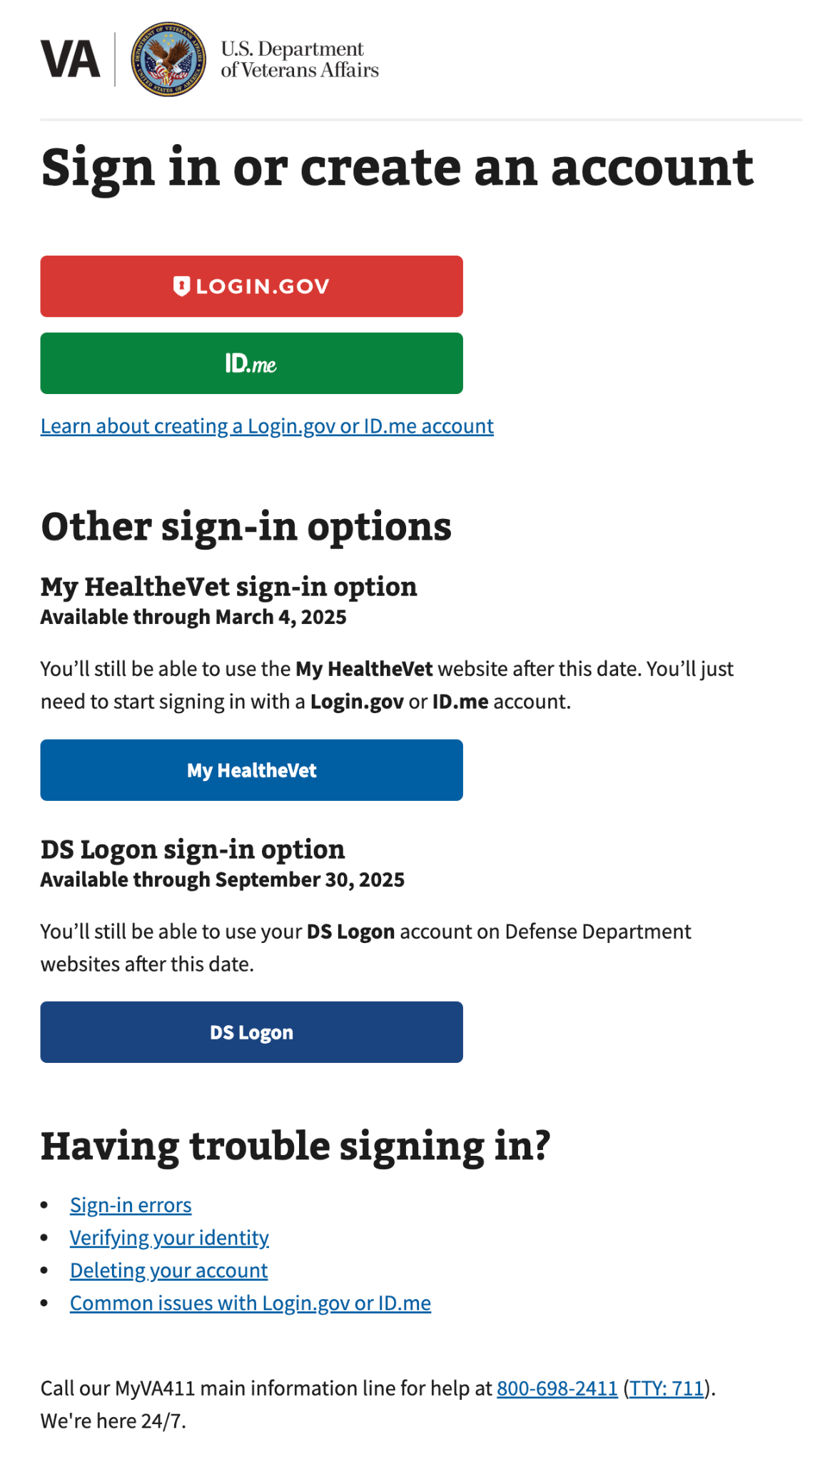

### Who can access these tools?

Active service members and Veterans who have logged in with Level of Assurance 3 (LOA3)—the highest level of identity verification on VA.gov—can access the Supplemental Claim form via [VA form 20-0095](https://www.va.gov/decision-reviews/supplemental-claim/file-supplemental-claim-form-20-0995/start).

### How can users access these tools?

Veterans can log in to VA.gov and access the COE using the identity verification partners Login.gov or ID.me. DS Logon and My HealtheVet will be available temporarily (see screenshot).

## Navigation

Users will access VA Form 20-0995 at <https://www.va.gov/decision-reviews/supplemental-claim/file-supplemental-claim-form-20-0995/start>.

Both digital and paper application instructions will be accessible at  
<https://www.va.gov/decision-reviews/supplemental-claim/>.   
The online VA Form 20-0095 application is only available for disability compensation claims. For other claim types, follow the instructions on the page to submit by mail, in person, or with an accredited representative.

## Functionality

### Supplemental claim form

#### Introduction page

Members must log in to start the application. Important: The Veteran’s account information (Social Security number, date of birth, etc.) must be verified before proceeding. If this information is not verified, the Veteran cannot start a supplemental claim on VA.gov.

All information shown in the screenshots in this document is fake test user data.

There are 4 log-in states:

1. Not signed in

Save time - and save your work in progress - by signing in before starting your request. 

When you’re signed in to your VA.gov account:

- We can prefill part of your request based on your account details.
- You can save your request in progress, and come back later to finish filling it out. You’ll have 60 days from the date you start or update your request to submit it. After 60 days, we’ll delete the request and you’ll need to start over.

Note: If you sign in after you’ve started your request, you won’t be able to save the information you’ve already filled in.

Sign in to start your request button

1. Signed in and ready to start (save-in-progress renders this)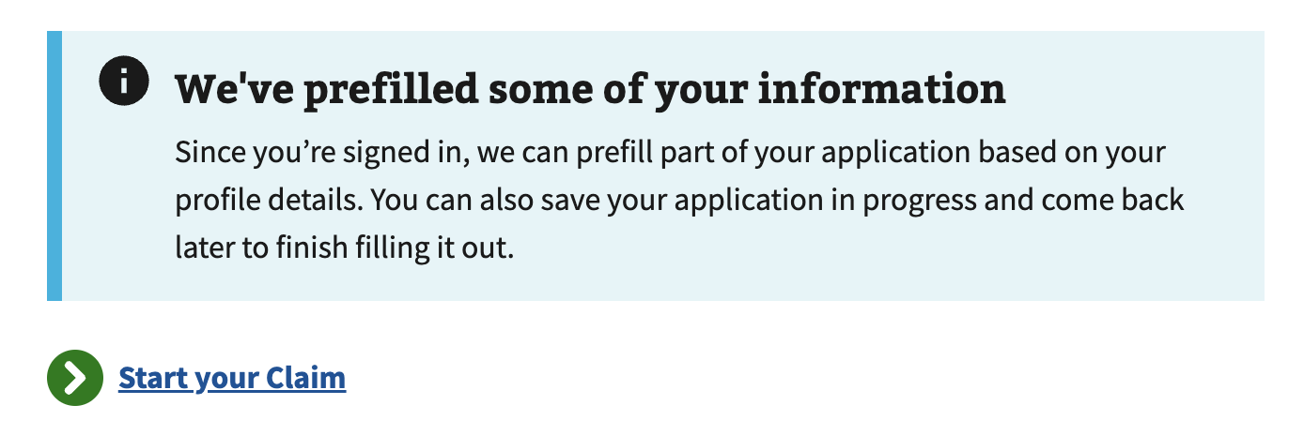
2. Signed in and not LOA3 verified



1. Signed in and missing either SSN or DoB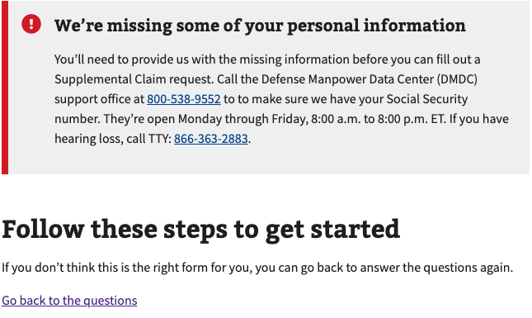

#### 

#### Getting started—Is this the form I need?

The claimant selects the type of claim they are filing for. This version of the supplemental claim form on VA.gov is only for disability compensation claims. Claimants are re-directed to the PDF form for non-disability compensation claims.

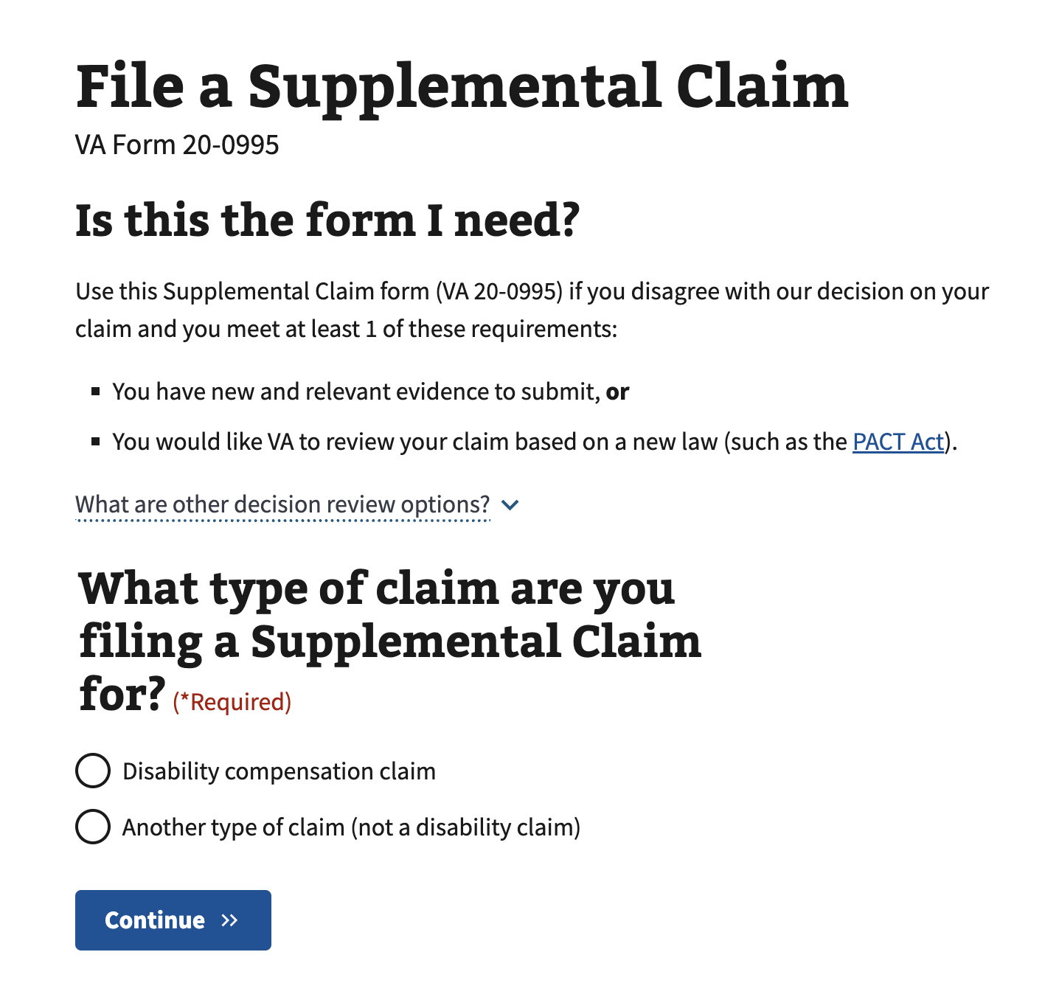

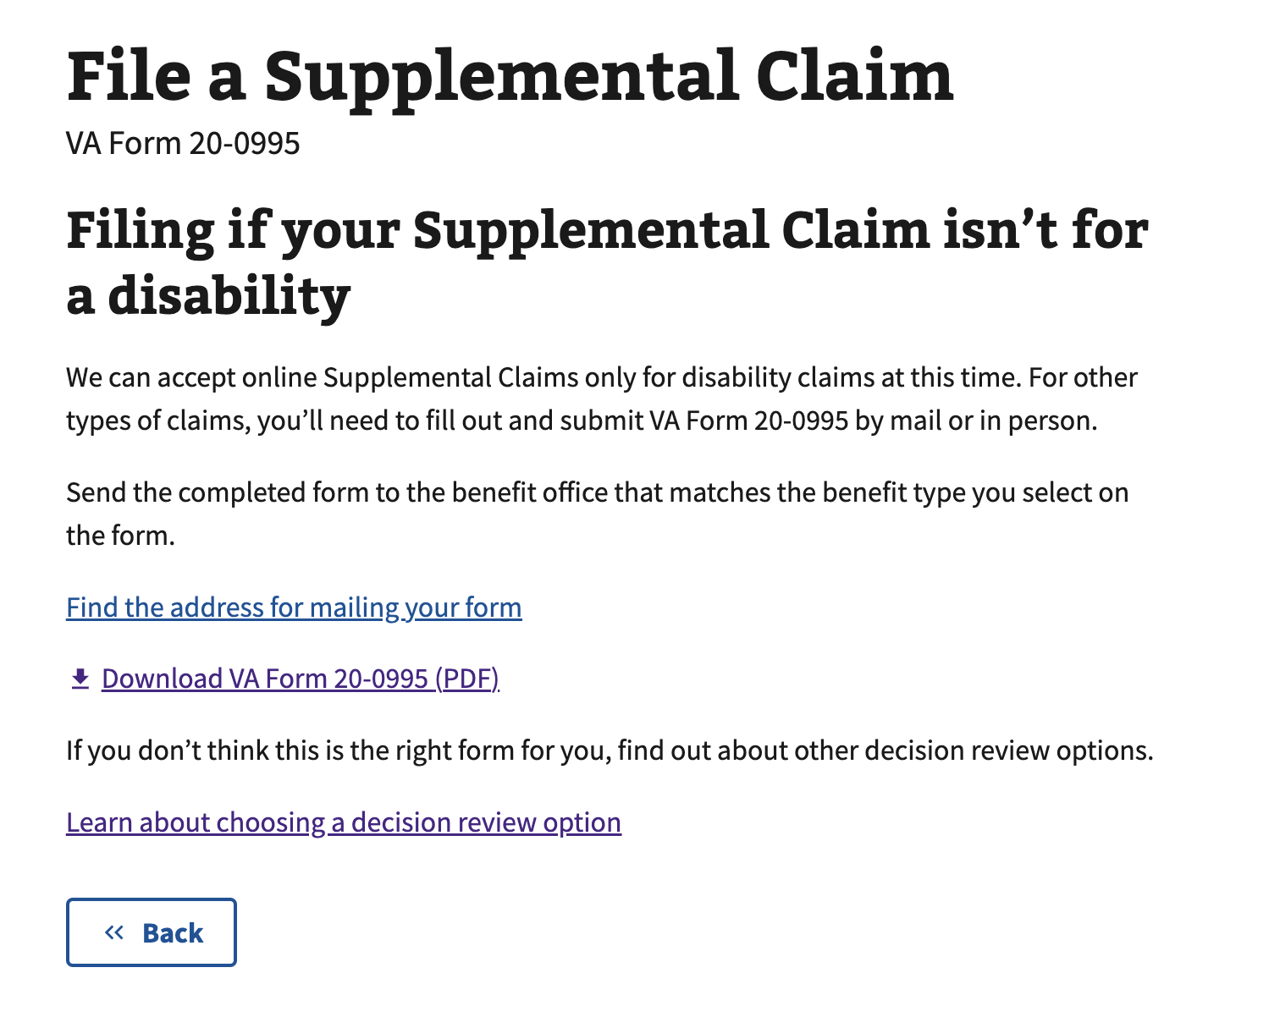

#### Getting started— Check your eligibility, gather info, and get started

Claimants can review content to help them determine if they are ready to file a supplemental claim before they start. They can also learn about what happens after they submit their claim.

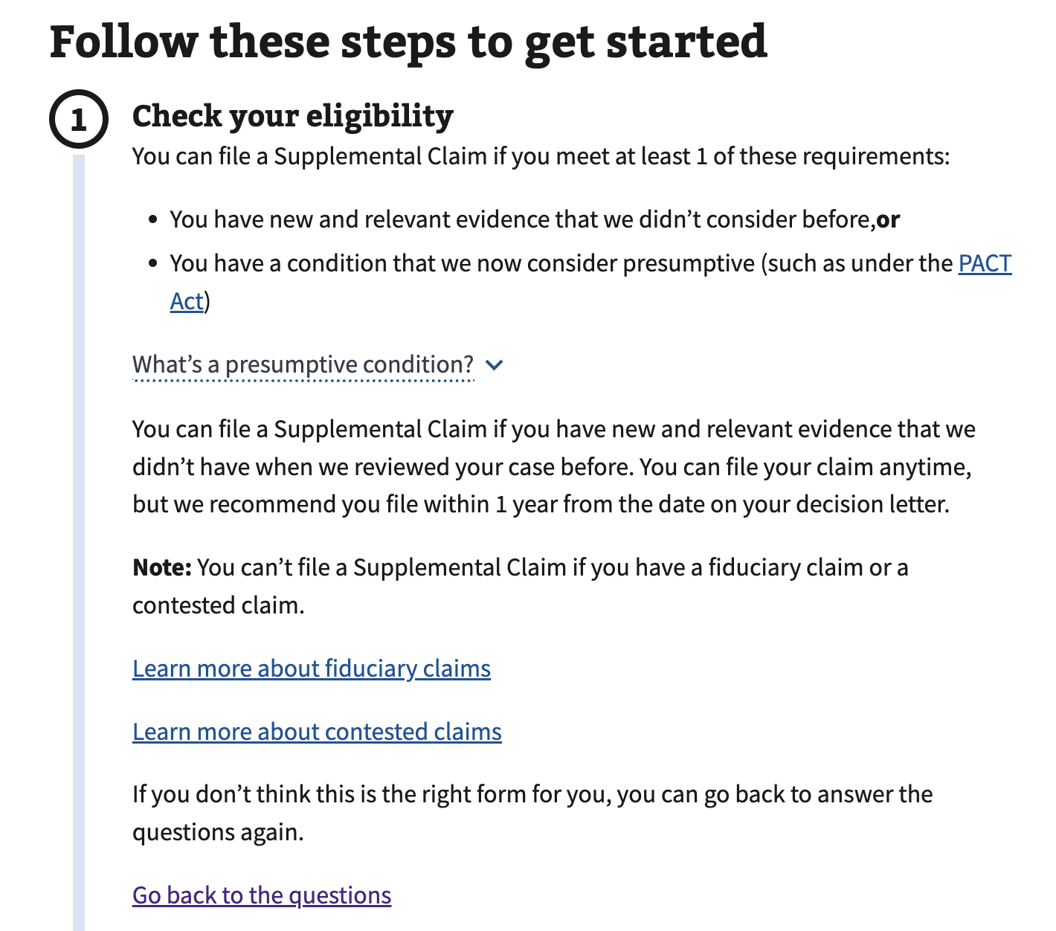

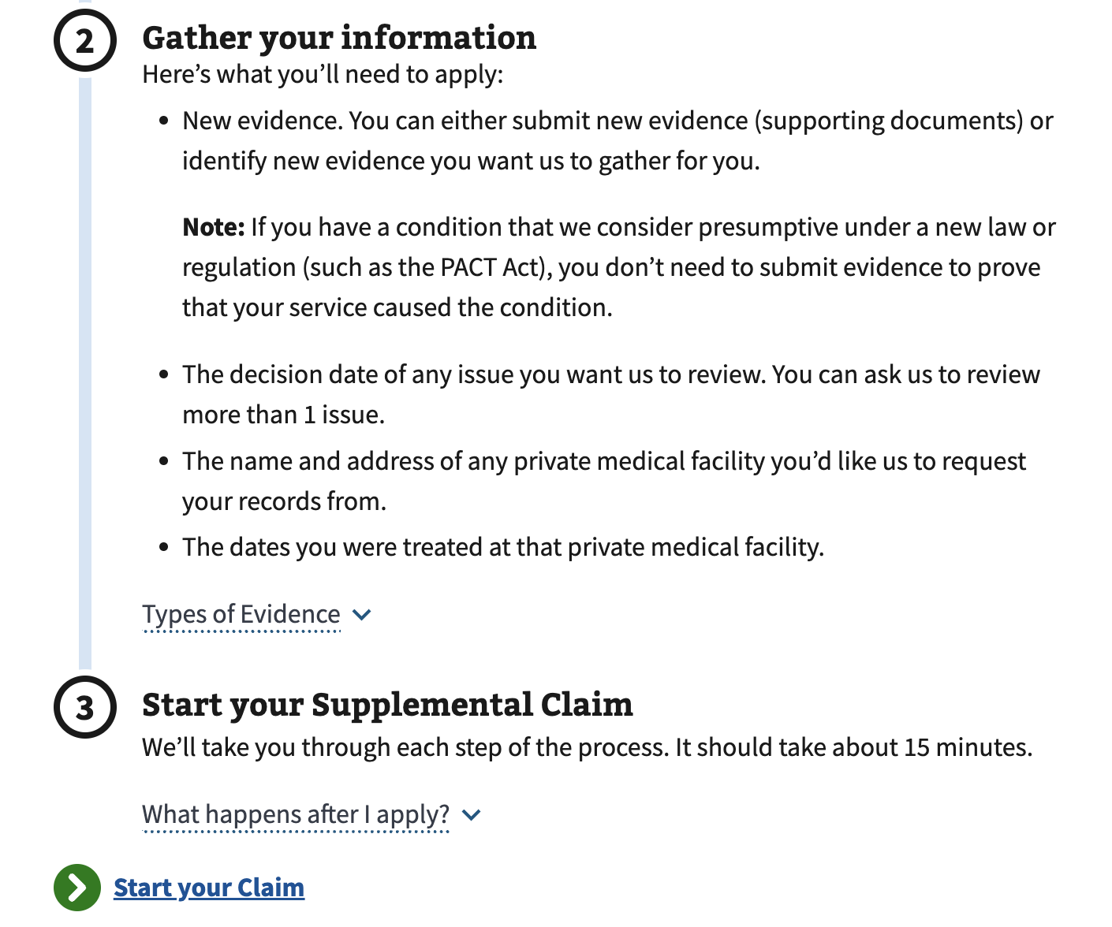

#### Intent to File

* When the claimant begins the supplemental claim form on VA.gov, an Intent to File (ITF) form is automatically submitted on their behalf. This form is a placeholder for the claimant's potential claim, securing an earlier effective date for their benefits.
* The user is notified of the expiration date if an existing ITF exists in VBMS.
* If claimants have concerns about how their Intent to File form is associated with their supplemental claim, please let them know that the claim processor reviewing both forms will pair them appropriately.
* Additionally, the ITF date for a supplemental claim applies only if the ITF is submitted more than a year after the decision date.

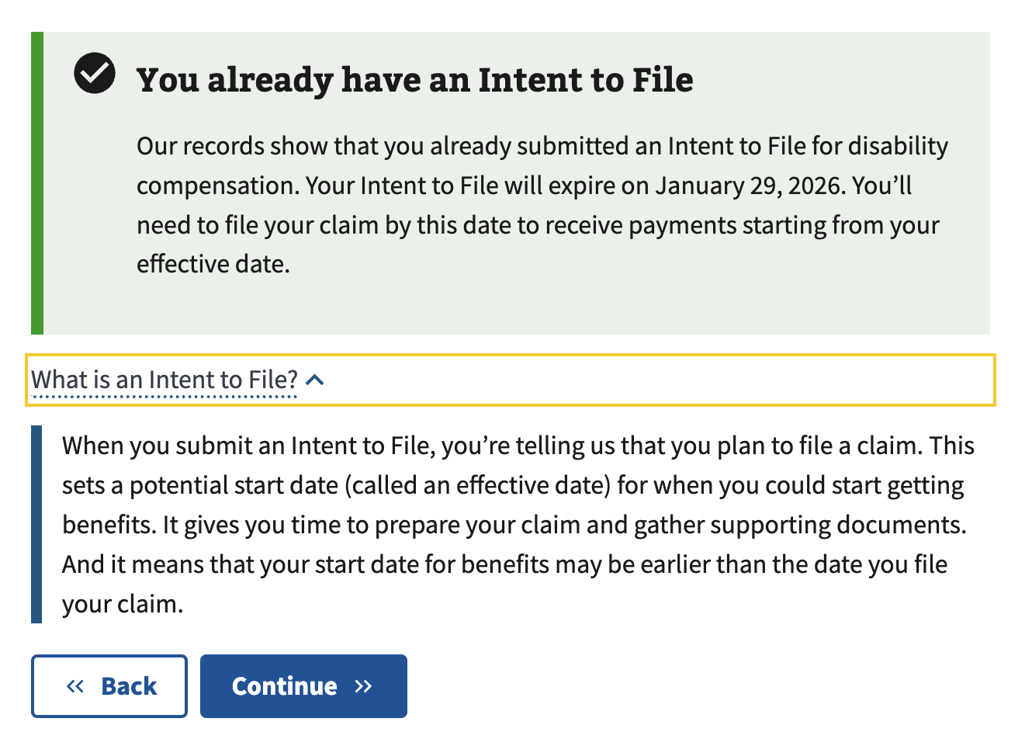

#### 

#### Form Step 1: Veteran information

Claimants can then review their Veteran information on this page.

#### 

#### 

#### Form Step 1: Veteran information: Are you experiencing homelessness or at risk of becoming homeless

Claimants can optionally declare whether they are at risk of becoming homeless. If they choose yes, they will see a few optional screens enabling them to describe their situation and provide a point of contact.

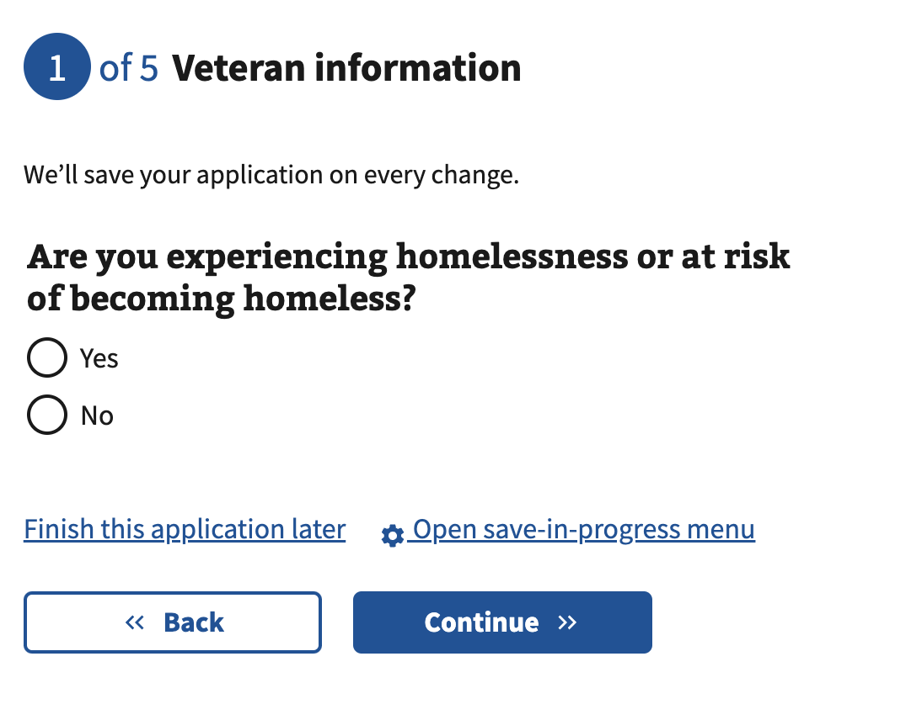

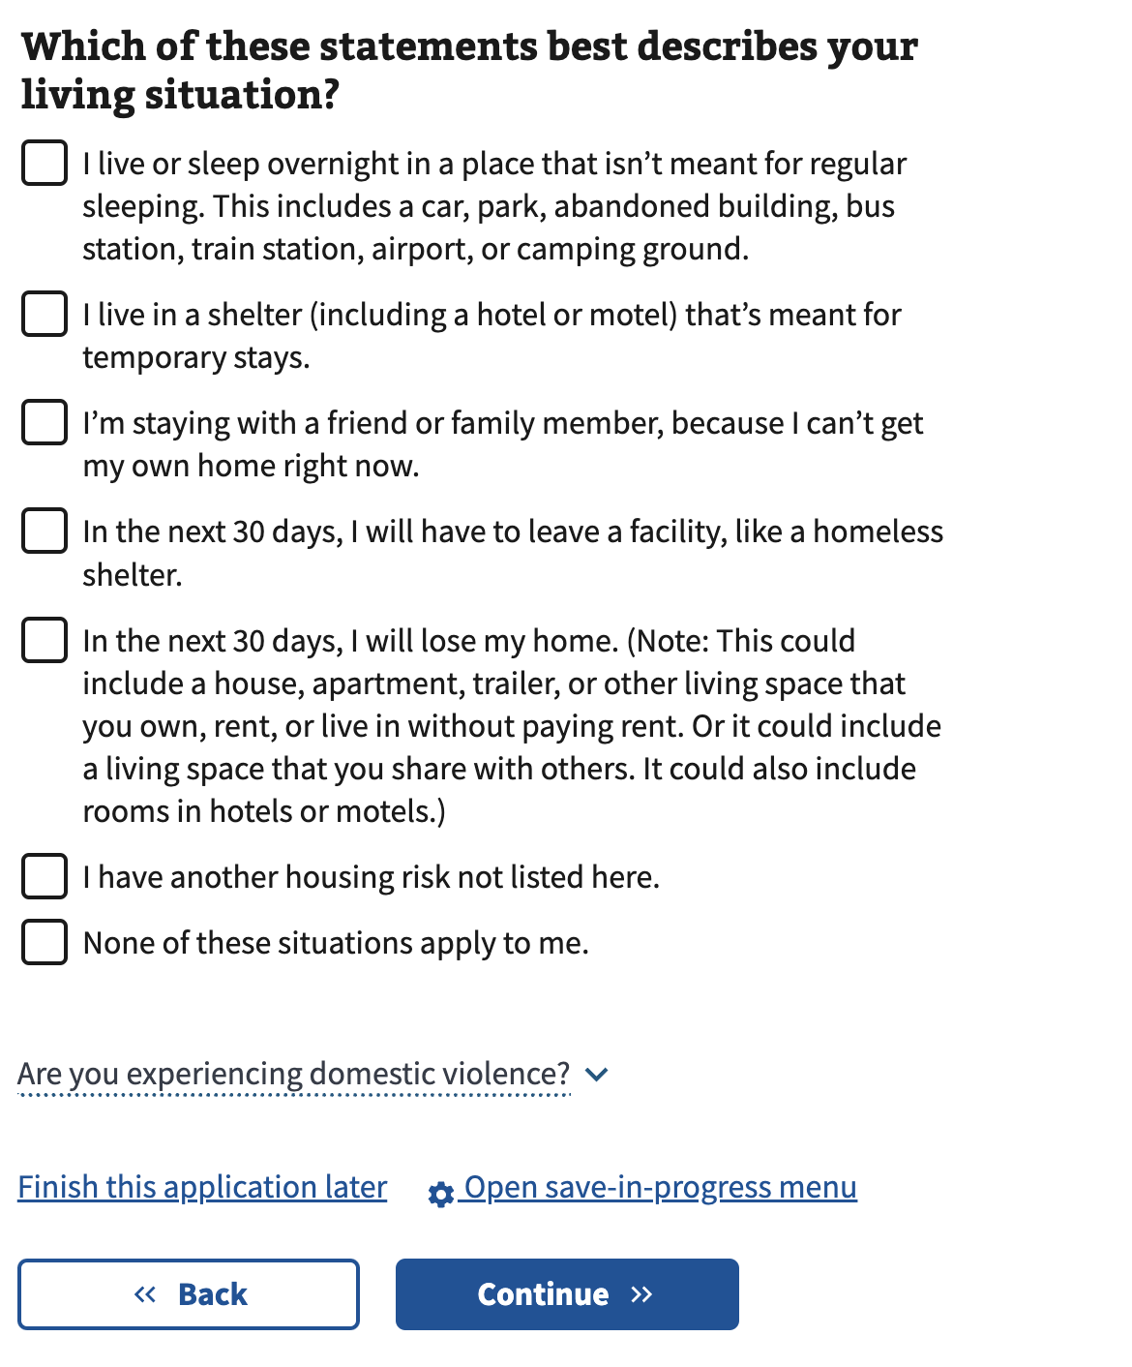

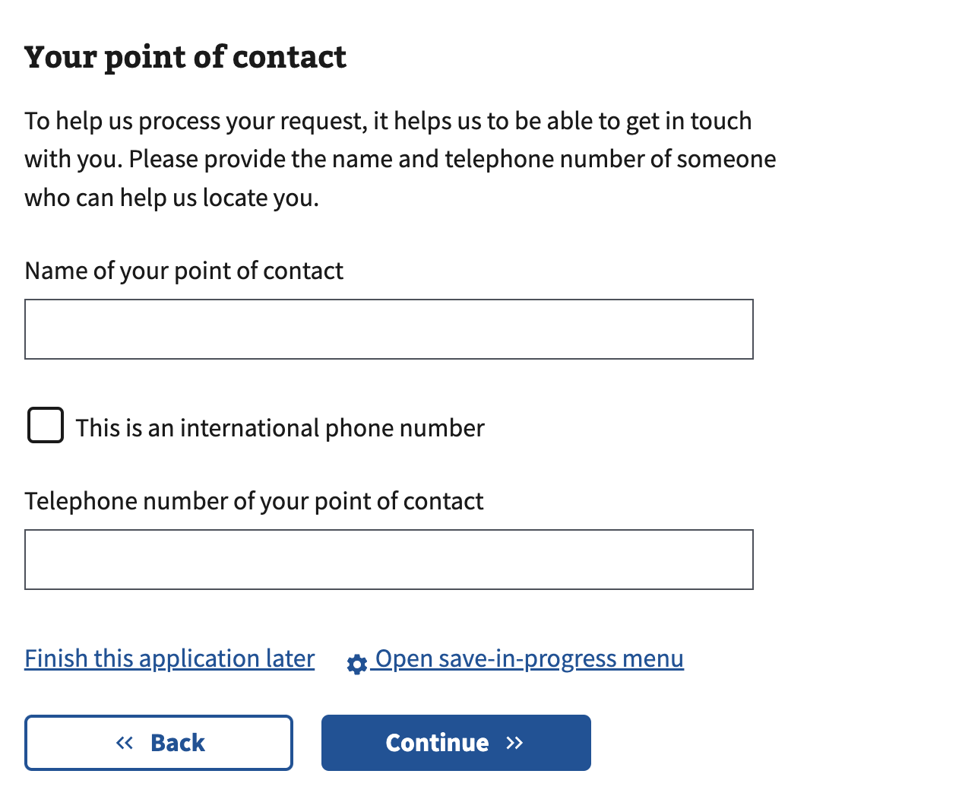

#### Form Step 1: Veteran contact information

Claimants can make edits to their contact information. Information updated here will also appear in their VA.gov profile. Mailing addresses are required unless they state they are at risk for homelessness. Then, the mailing address becomes optional.

#### 

Claimants select their primary phone number on this page.

#### 

#### 

#### 

#### Form Step 2: Add issues to the claim

* Claimants must select or add issues that VA has decided to include in their claim.
* Issues that have received a decision will be pre-populated.
* They can add multiple issues to a single claim, including previously decided issues they think are or are not PACT eligible.

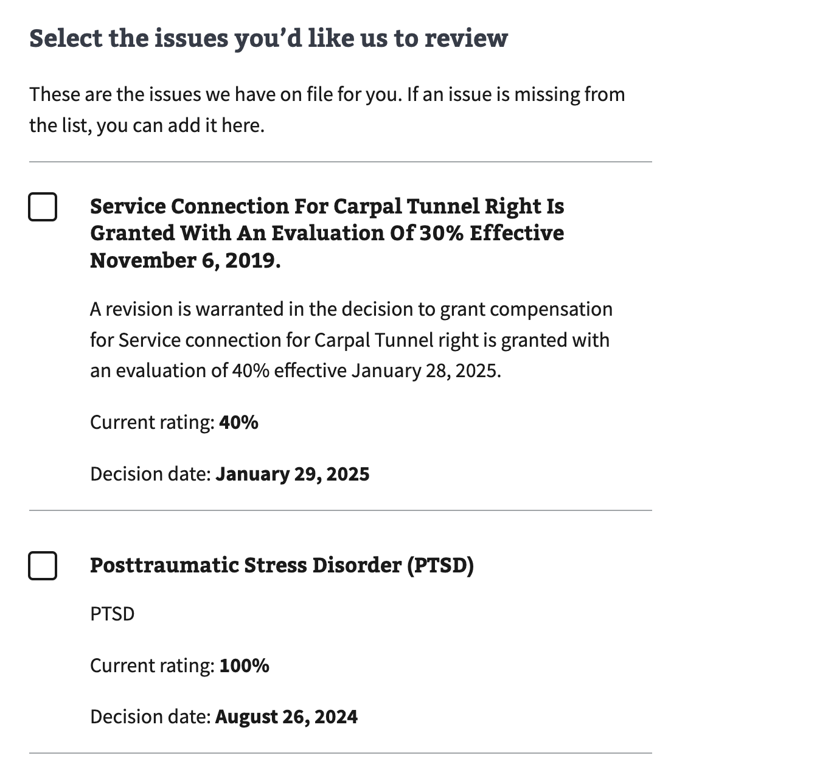

#### Add new issues to the claim

Only issues for which the claimant has received a VA decision notice can be added to a claim. If the claimant files an initial claim, they must use VA Form 526EZ, not the supplemental claim form.

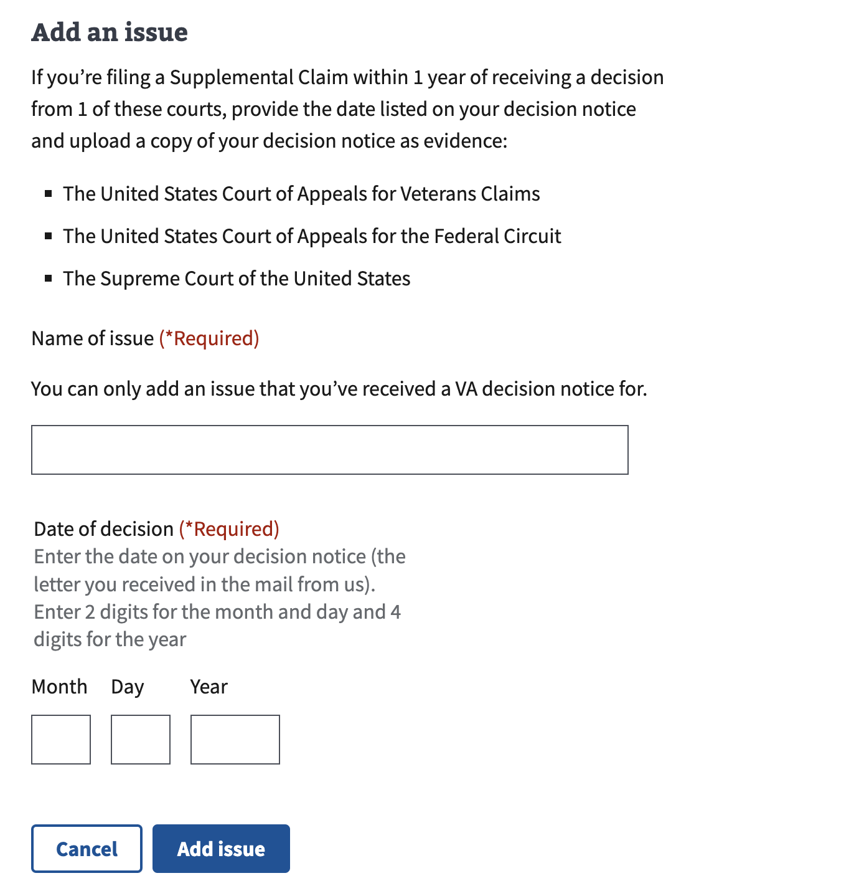

**Step 2: Opt into the AMA decision review process**

The form will explain the AMA decision review process, which helps process their claim more efficiently if it was decided on before February 19th, 2019. This explanation shows only when the claim has contestable issues in the legacy process or if the Veteran adds an issue that wasn’t pre-populated.

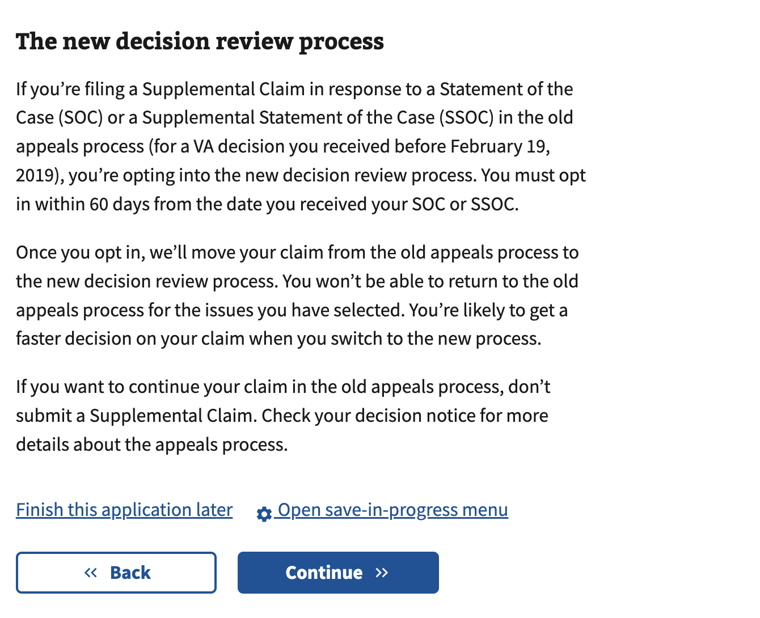

**Form Step 3: Notice of evidence needed**

* Claimants must check the box to confirm that they have reviewed the “Notice of Evidence Needed,” which explains the evidence they must submit with their supplemental claim.
* If the claimant thinks they have a presumptive condition related to the PACT Act, they can submit the form.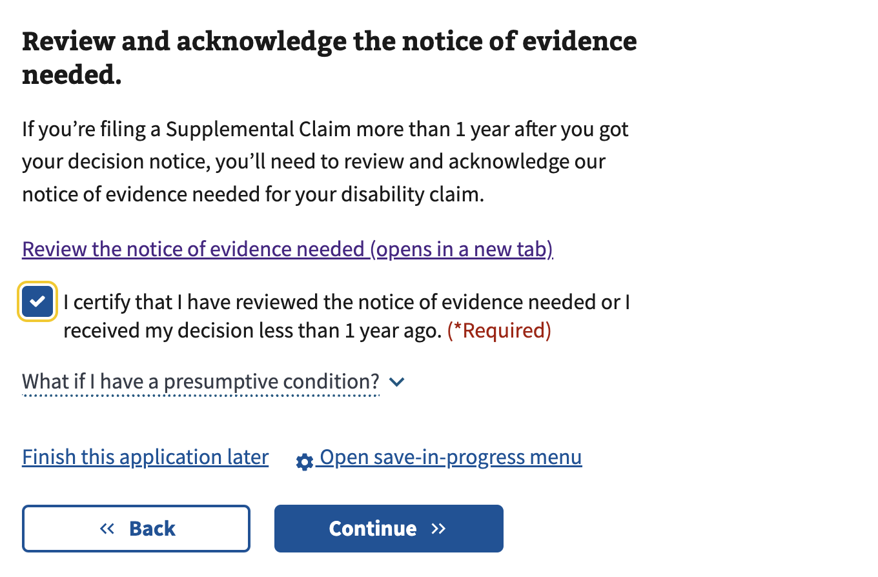

#### Form Step 3: Types of facilities

Claimants can select all the different types of facilities where they’ve received treatment.

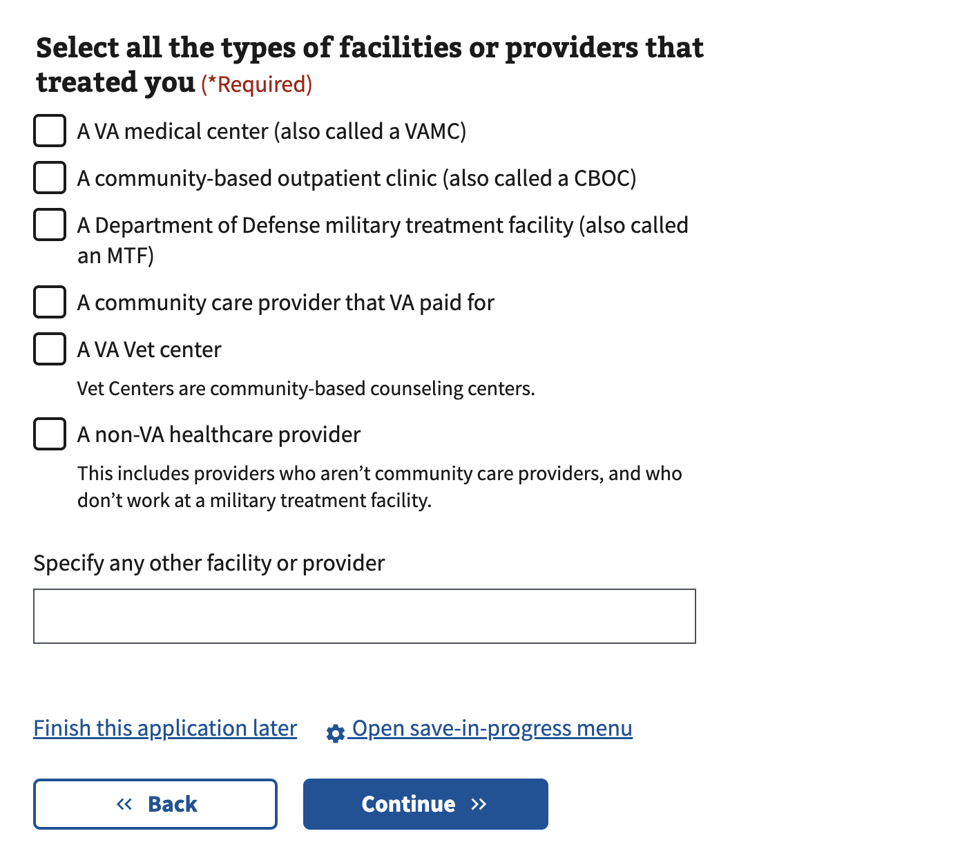

#### 

#### Form Step 3: Request for VA medical evidence

Claimants can optionally allow VA to gather their VA medical records on their behalf.

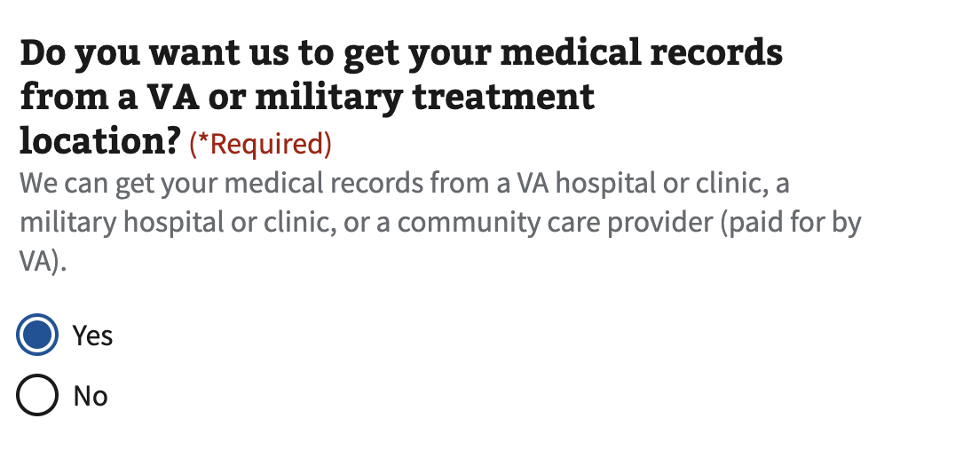

* If they select “yes,” they must add the names of VA facilities. The treatment dates after 2005 are optional. They can also add multiple VA facilities.
* This step only appears if the user allows VA to gather VA medical evidence.

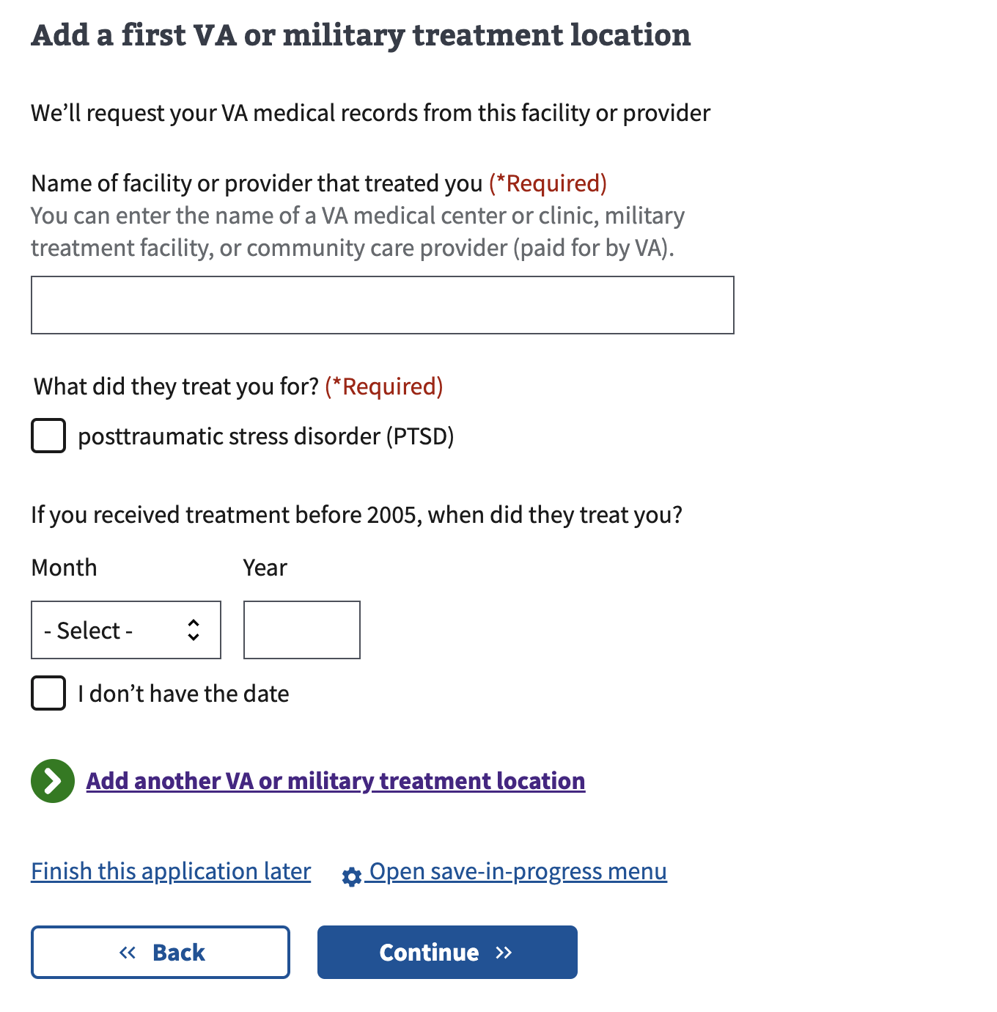

#### 

#### Form Step 3: Request for private medical evidence

Claimants can fill out an ancillary VA Form 21-4142(a) within the digital form, which optionally allows VA to gather their private medical records on their behalf.

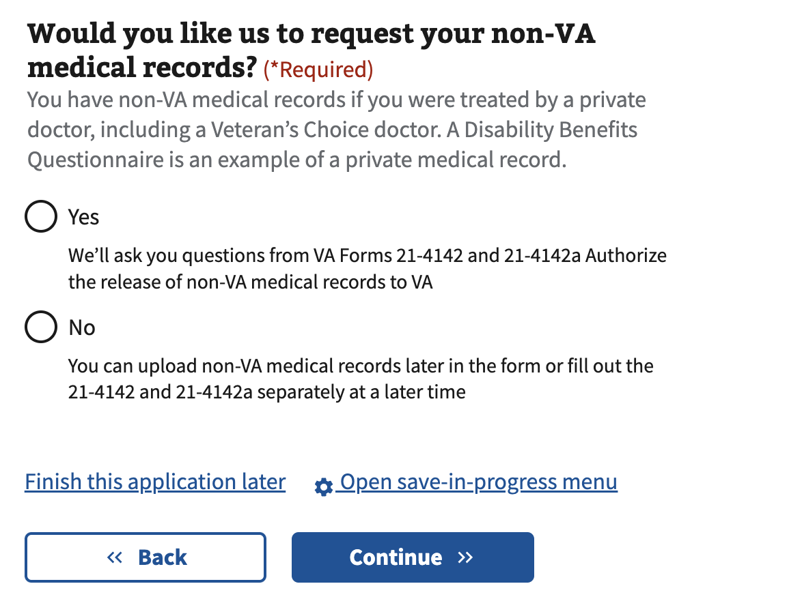

* If they select “yes,” they must authorize VA to gather their private medical records on their behalf by checking the box at the bottom of the page.
* This step only appears if the user allows VA to gather private medical evidence.

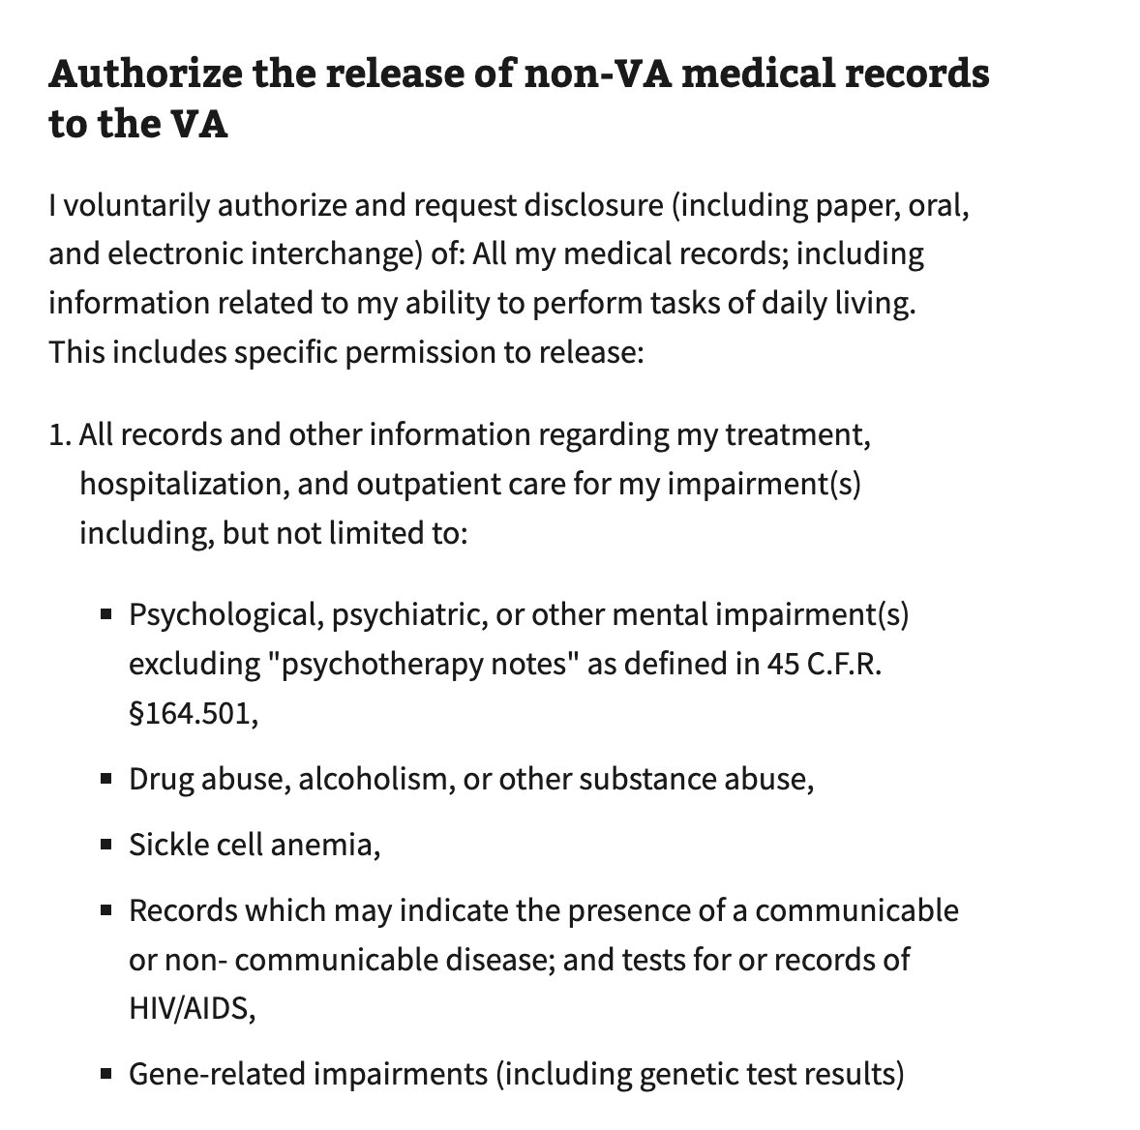

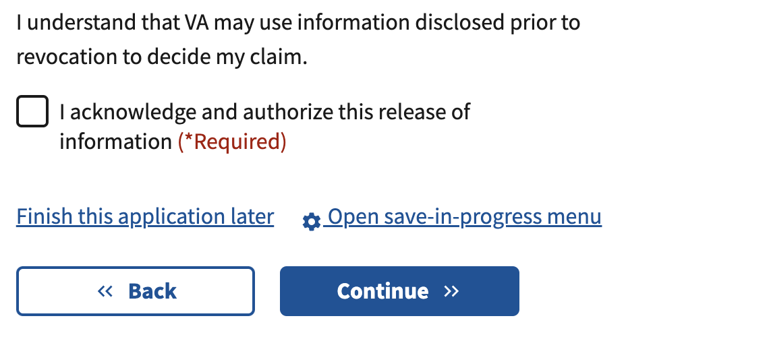

Claimants can optionally limit the private medical record information that VA has access to by describing the limitations in a text box. This is only shown if the user allows VA to gather private medical evidence.

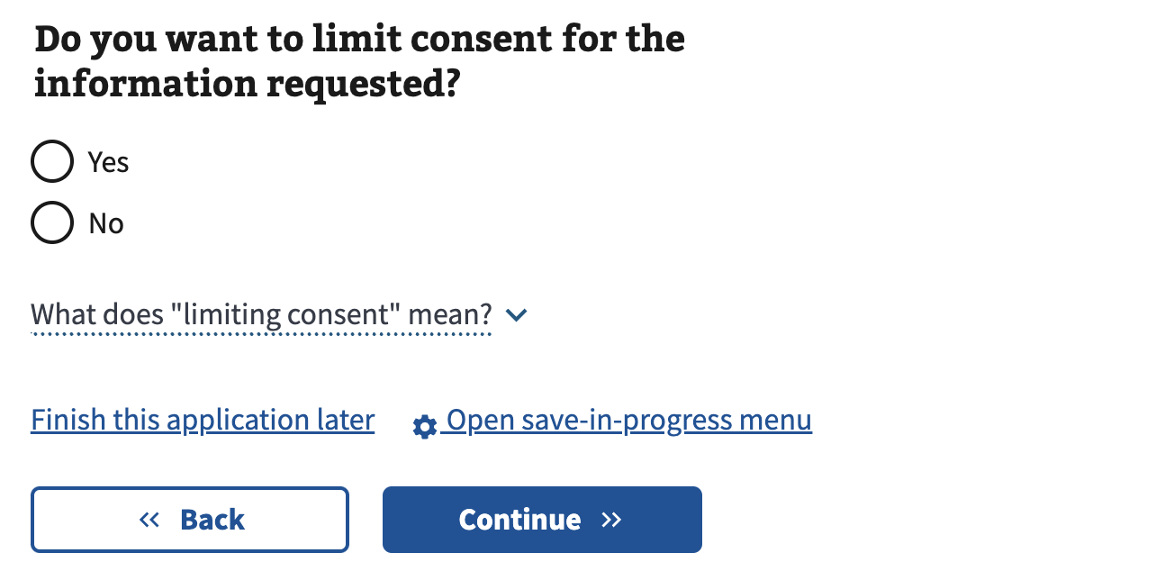

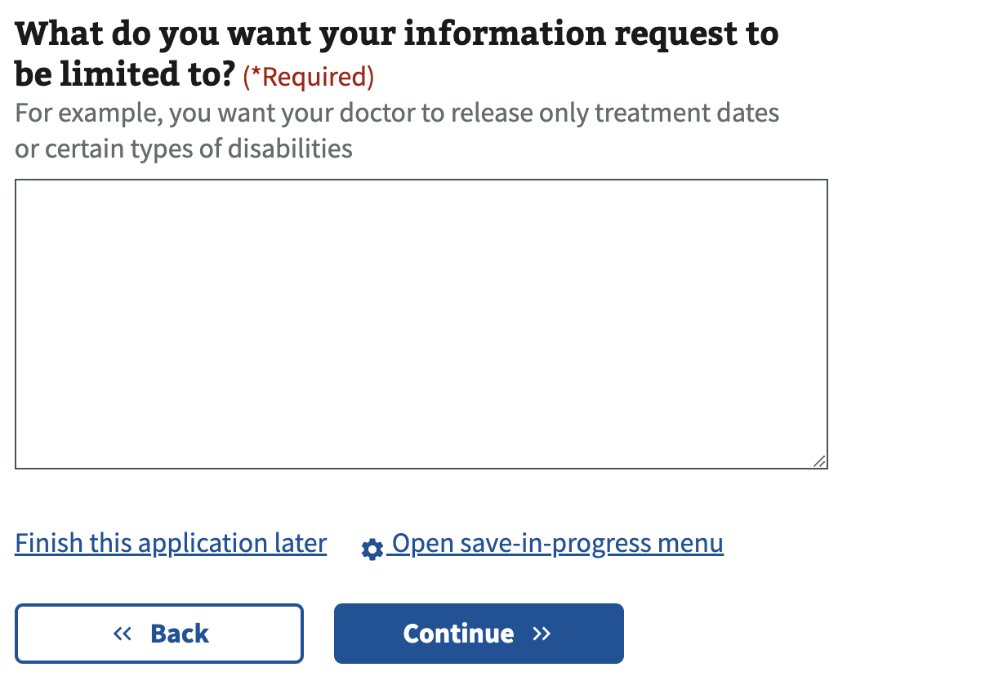

They must also add the private facility names and treatment dates for their treatment. They can add multiple VA facilities. This is only shown if the user allows VA to gather private medical evidence.

#### Form Step 3: Upload your records or other documents

Claimants can also optionally upload their evidence or ancillary forms that they filled out as PDFs.

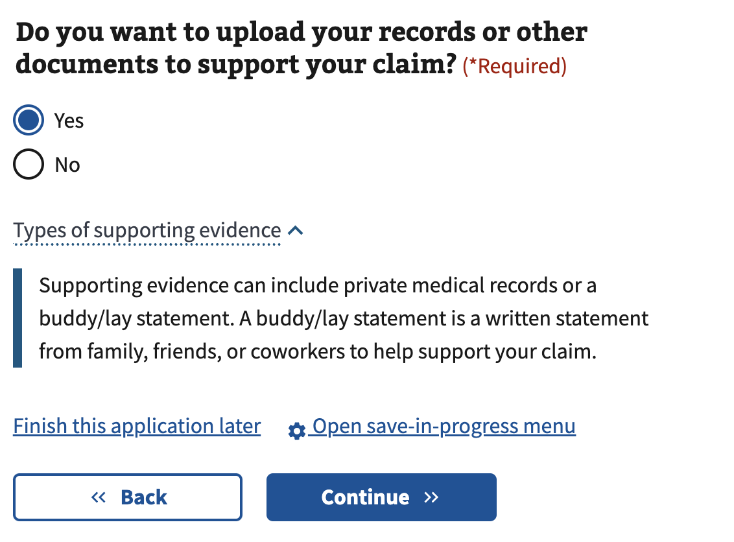

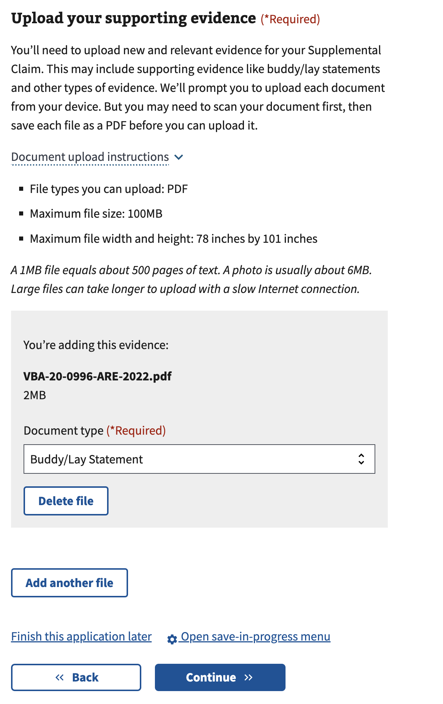

#### Form Step 3: Review the evidence you’re submitting

Claimants can review the information submitted as evidence, including uploaded documents. They also have the chance to add more evidence through the action link.

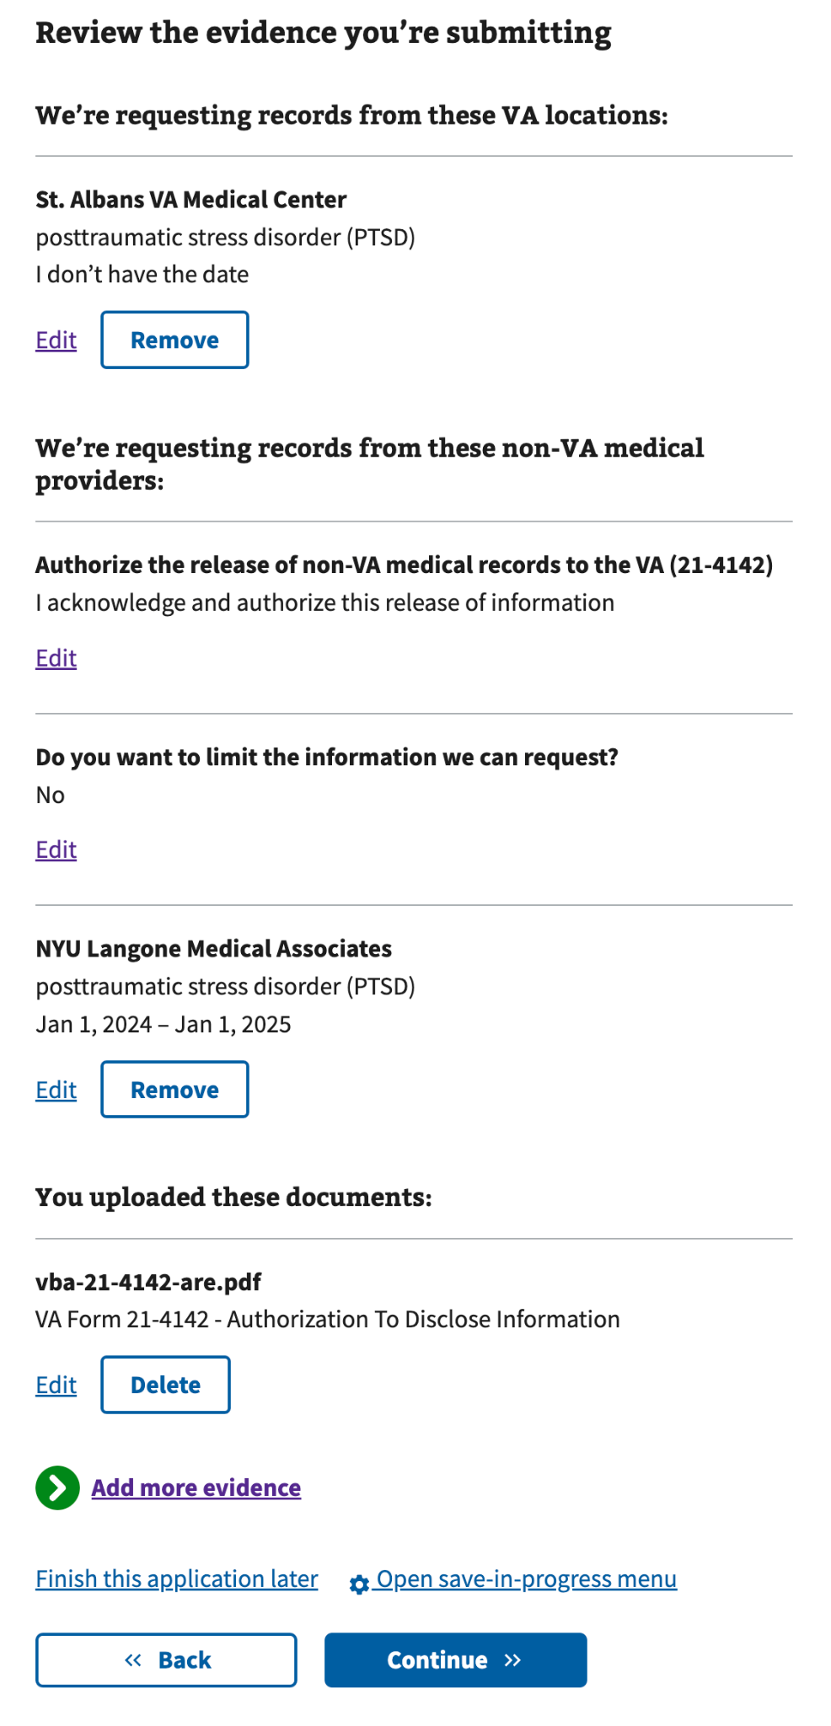

If they do not add any evidence, a warning will appear that encourages them to add evidence.

#### 

#### Form Step 4: Optional indicator for Veterans with claims related to Military Sexual Trauma (MST)

Claimants have the choice to view an option available for Veterans who have a claim related to MST. If they choose “yes,” they see the complete language for the notification and are given options for permission to add or remove an indicator on their Veteran’s Health Administration file.

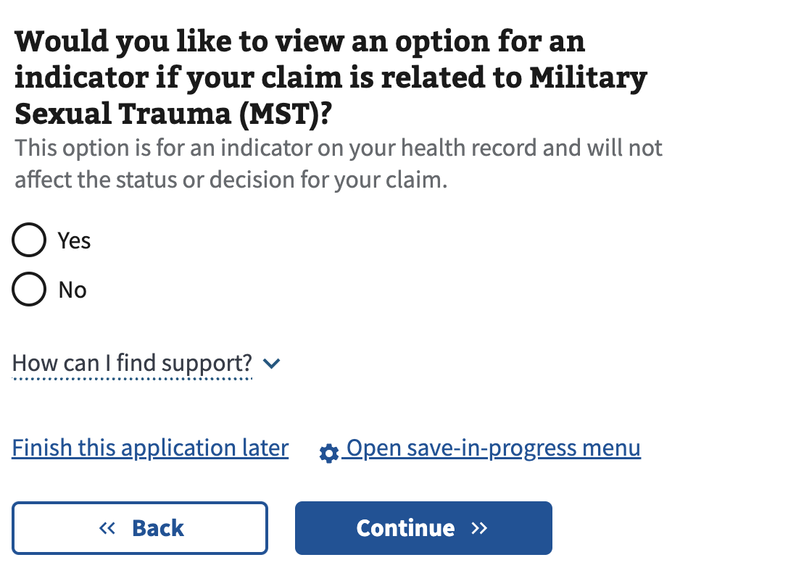

#### 

#### 

#### 

#### 

#### Form Step 5: Review and submit

Before claimants submit, they can conduct a final review of the info they provided.

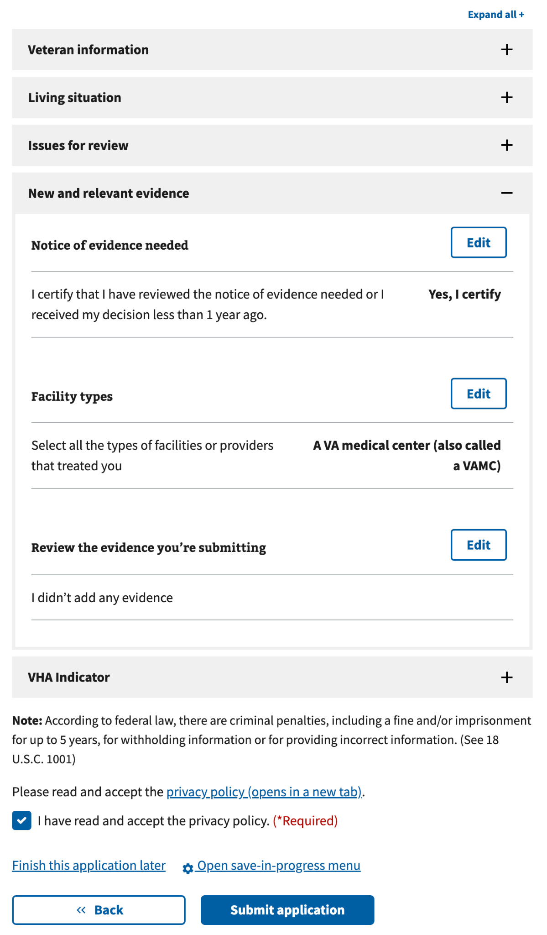

#### 

#### Confirmation Page

After a successful submission, a confirmation page appears. Claimants are also shown a plain-language HTML version of their submission with their answers.

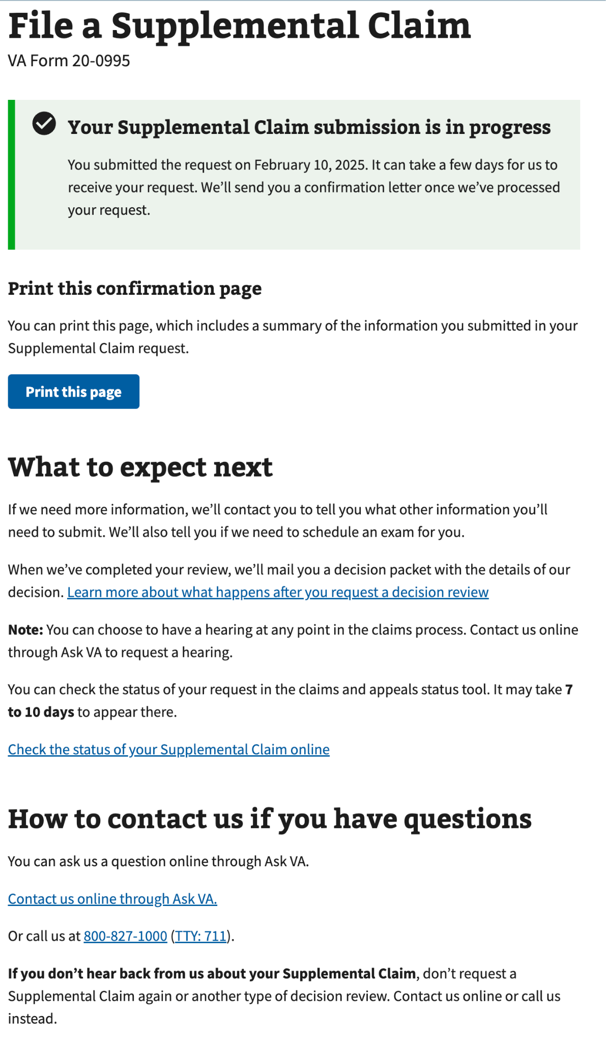

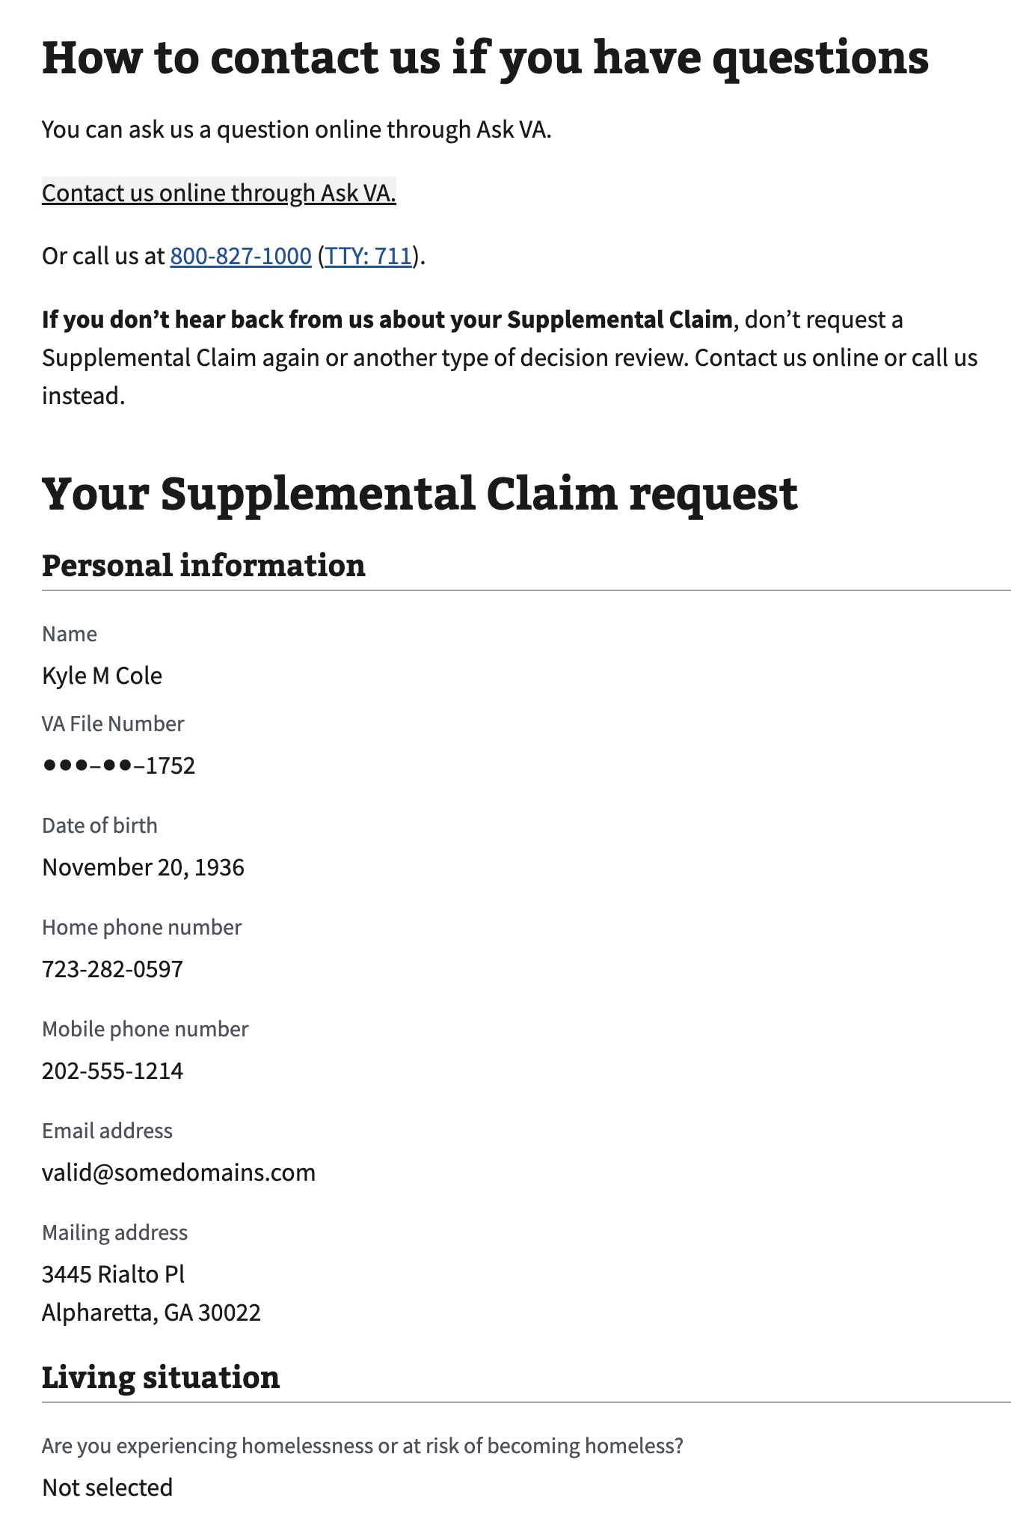

## Major Issues and Error Messages

Veteran information validation errors

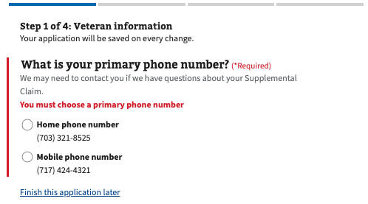

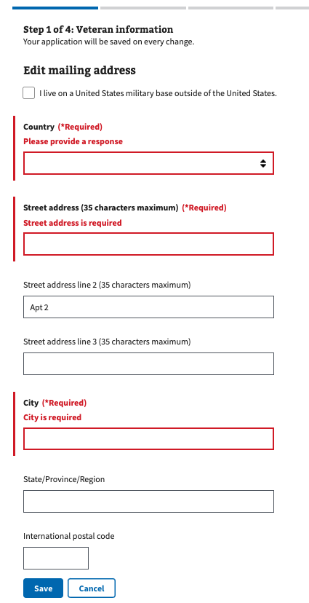

**Eligible issues validation error**

Instruction: Our record system has no known issues on which VA previously made a decision. If the Veteran receives this, please advise them to click “Add a new issue” to add their issue to the claim manually. Please also remind them that the supplemental claim form is only for matters that VA previously decided on. Veterans will know whether or not the issue received a decision based on their decision letters. If the Veteran cannot find their paper decision letters, they can download them in the claim status tool on VA.gov.

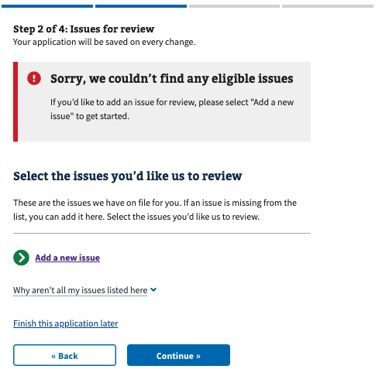

**Notice of acknowledgment validation errors**  
  
Veterans must check the box below this section to continue.

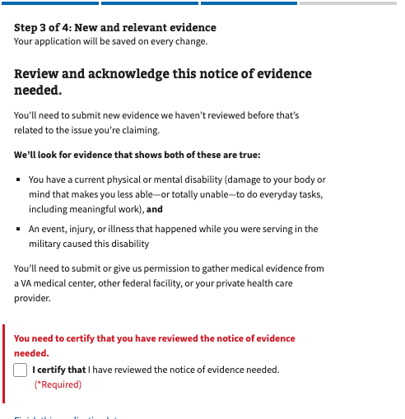

**Evidence-gathering validation errors**  
  
Veterans must select Yes or No when asked if they would like VA to gather their VA or private medical records on their behalf.

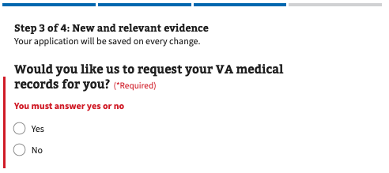

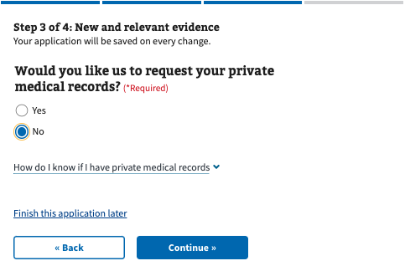

**Private evidence-gathering validation errors**  
  
To allow VA to gather private evidence on the Veteran’s behalf, they must check the box below the section titled “We need your authorization to request your medical records” to continue. If they do not want to authorize this, they can press the back button and select No when asked, “Would you like us to request your private medical records?”

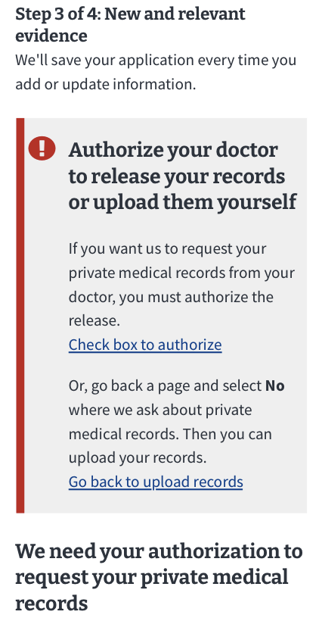

**Submission error**  
  
If VA.gov's backend system is down or there are connectivity issues with the claimant’s internet connection, they will see an error preventing them from submitting. If this appears, reassure the claimant that their application has been saved and that they may have to wait for the system to come back online before submitting again.

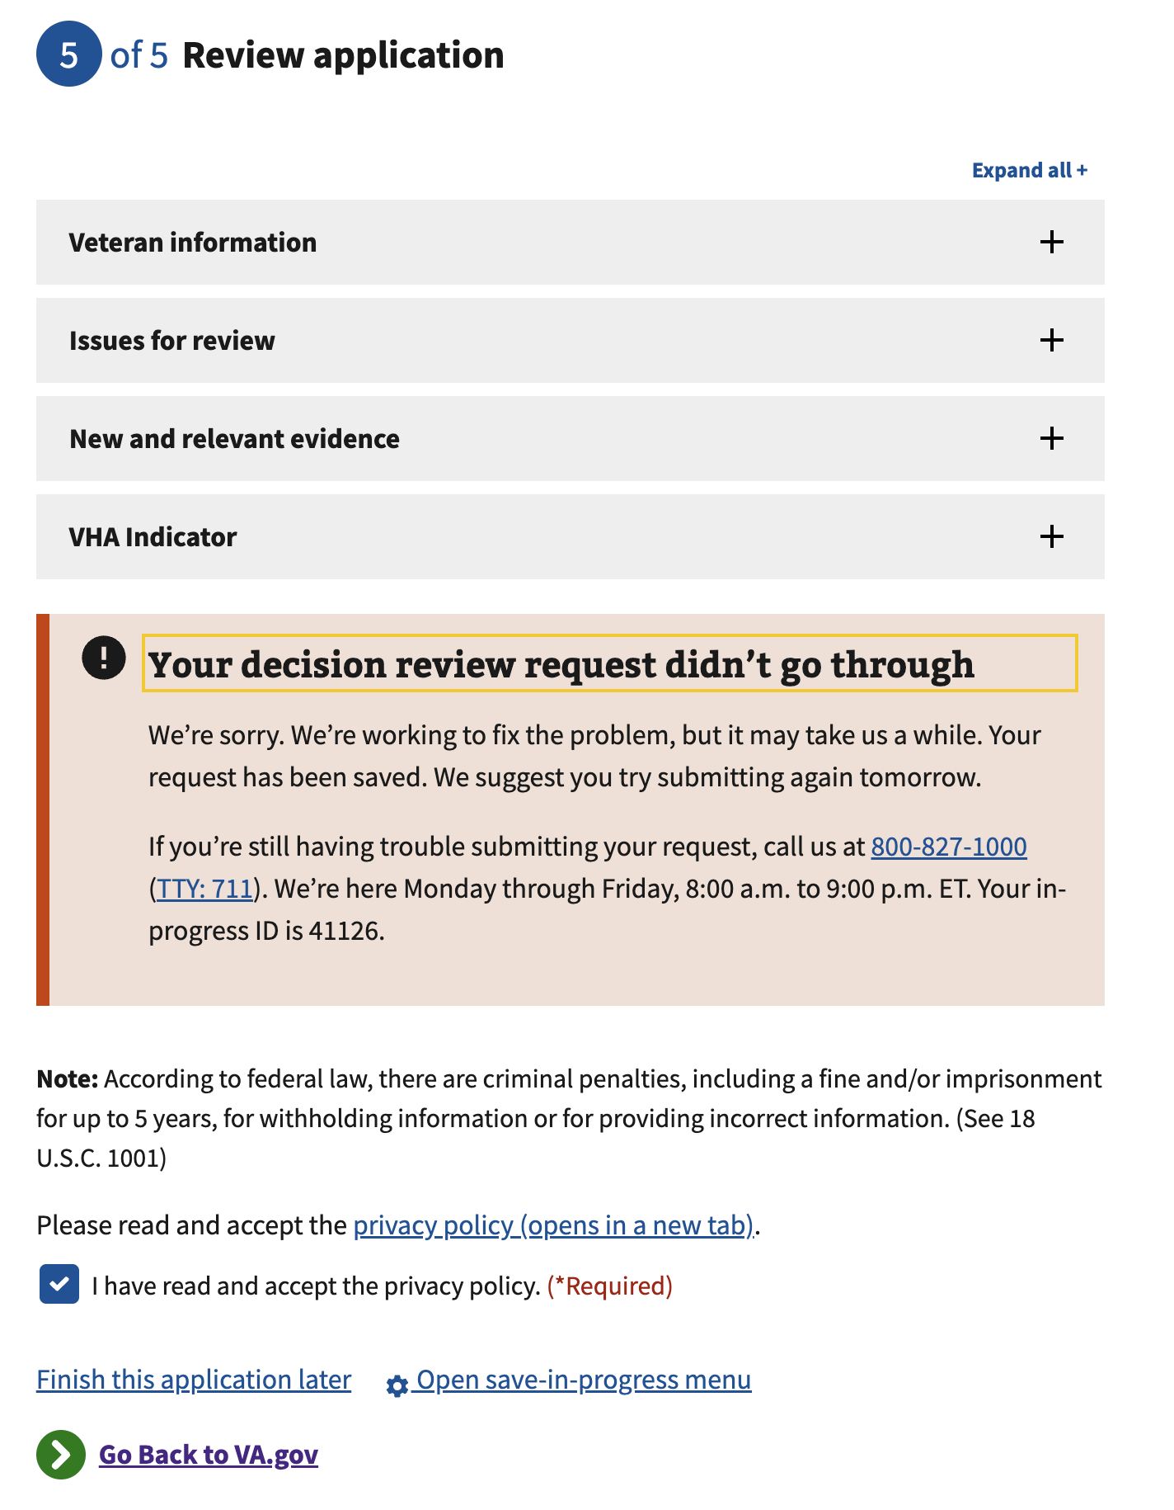

## 

## Frequently Asked Questions

### Supplemental Claim VA Form 20-0095

Here are some common scenarios that Veterans may experience when filing their claim.

### Should I file a supplemental claim?

Supplemental claims are filed for claims that VA previously denied. If the Veteran’s claim was not previously denied, if the Veteran is filing a claim for an increase, or if the Veteran has not filed a claim before, the 526EZ may be the proper form for them to use.

For more information about how to choose the right type of form for their claim, they can visit these pages on VA.gov:

* <https://www.va.gov/disability/how-to-file-claim/when-to-file/>
* <https://www.va.gov/resources/choosing-a-decision-review-option/>

### What kind of issues can I add to my supplemental claim?

Veterans may add any issues that VA previously denied. If they are available in our record system, we will display them on VA.gov. Issues that VA did not decide on are not eligible for a supplemental claim and will not appear as an option to select on the form on VA.gov.

Veterans can check their decision letters to see which issues VA denied.

If VA has denied the Veteran for an issue that does not yet appear on VA.gov, they may manually add that issue to their claim.

### My claim may fall under the PACT Act. Should I file?

VA.gov is accepting PACT Act claims. If the Veteran believes their claim is PACT eligible, they should submit it, with or without evidence. VA will manually review all claims to determine if more evidence is needed and will contact the Veteran directly. Evidence can be shared through VA.gov using the claim status tool.

### I don’t think my claim falls under the PACT Act. Should I file?

If the Veteran believes their claim is not PACT eligible, they should submit it with evidence, but they will be allowed to submit it without it. VA will manually review all claims to determine if they are PACT eligible or if more evidence is needed, and it will contact the Veteran directly. Evidence can be shared through VA.gov using the claim status tool.

## Email error notification If the supplemental form fails at any point after submission, we will send the Veteran an “action needed” email notifying them that their submission has failed and that they should resubmit the form by mail or in person to avoid further issues.

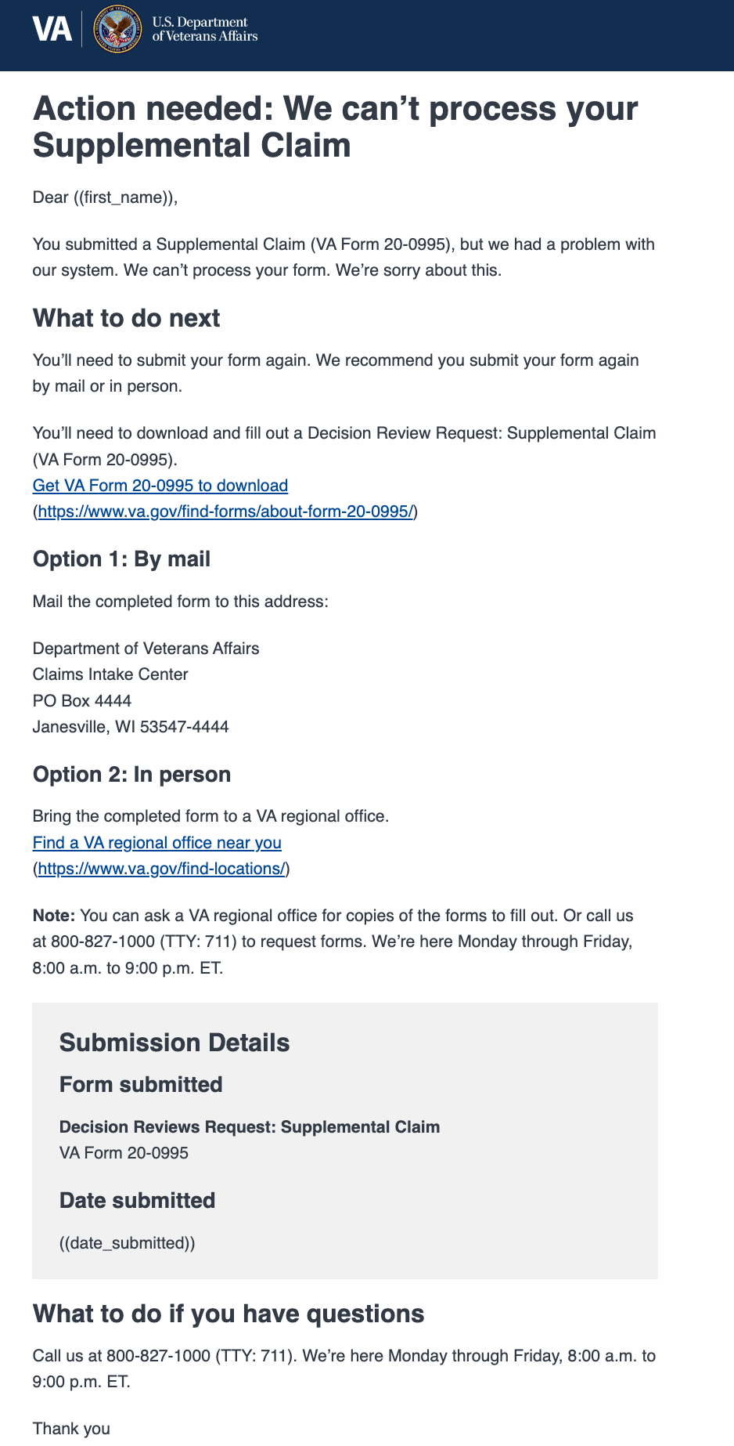

Suppose the supporting document fails at any point after submission. In that case, we will send the Veteran an “action needed” email notifying them that their submission has failed and that they should resubmit the form by mail or in person to avoid further issues.

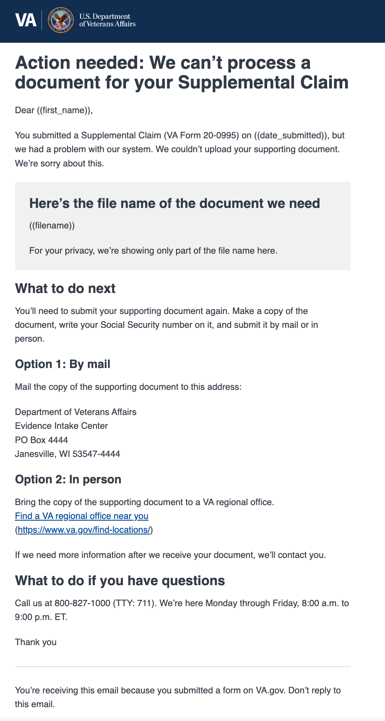

### 

### VA Form 21-4142

Suppose the supporting form fails at any point after submission; we will send the Veteran an “action needed” email notifying them that their submission has failed and that they should resubmit the form online or by mail to avoid further issues.

